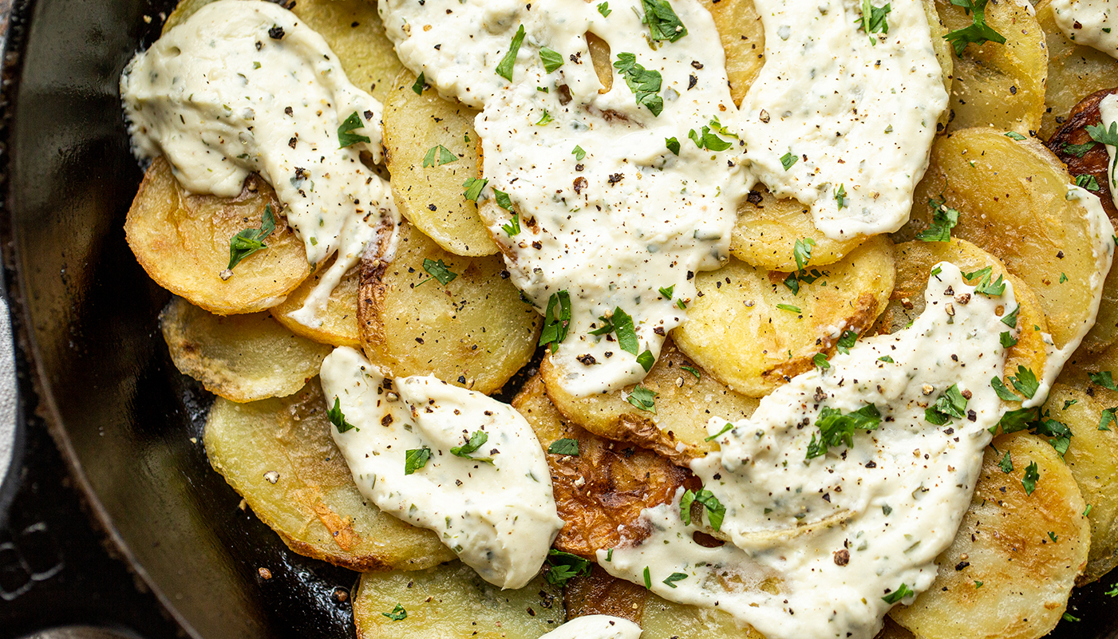

Creamy Garlic and Herb Skillet Potatoes

Yield: | Prep Time: | Cook Time: | Ready Time:
2 – 3 servings | 10 Minutes | 15 Minutes | 25 Minuets

Create your own signature house-made potato chips or use this recipe. We’ll never tell!

Ingredients:
- 1 (1lb) bag A Cut Above Fresh-Cut Sliced Potatoes
- ¼ cup vegetable oil
- As needed salt and pepper
- 2 tablespoons unsalted butter
- 5 ounces soft garlic and herb cheese (like Alouette, found in the packaged cheese aisle)
- 2 tablespoons lemon juice
- Fresh parsley for serving, optional

Preparation:
- Preheat the oven to 450°F.
- Empty the A Cut Above Fresh-Cut Sliced Potatoes into a large pot and cover them with water just until the water is about 2 inches above the potatoes. Place the pot on the stove and bring it to a boil over high heat. Reduce the heat to medium. Allow the potatoes to cook for 5-7 minutes or until they are just fork-tender. Drain the potatoes and set aside.
- While the potatoes are draining, place a cast-iron skillet with the vegetable oil over medium heat and allow it to heat up for 3-4 minutes.
- Carefully add the potatoes down in one even layer. Cook the potatoes for 3-4 minutes on each side until they are golden brown. Remove them from the oil and season them with salt and pepper.
- Drain the oil from the pan and add the butter. Return the potatoes to the pan in one even layer in the melted butter.
- Spoon the garlic and herb cheese over the potatoes and place the skillet into the preheated 450 F oven for 3-5 minutes until the cheese begins to melt. Remove the potatoes from the oven
- Drizzle the potatoes with lemon juice and parsley, if using, and serve them immediately.

